Wonga Beach State School

2024-2027
Student
Code of Conduct
Equity and Excellence: realising the potential of every student
Equity and Excellence outlines the government's vision for a progressive, high-performing education system. Equity and Excellence provides clarity for schools about priorities and expectations, with differentiated support targeted to each school's context and needs.
Queensland Department of Education

Purpose

Wonga Beach State School is committed to providing a safe, respectful and disciplined learning environment for all students, staff, parents and visitors.

The Wonga Beach State School Student Code of Conduct sets out the responsibilities and processes we use in our school to promote a productive, effective whole school approach to discipline.

Its purpose is to facilitate high standards of behaviour from all in the school community, ensuring learning and teaching in our school is prioritised, where all students are able to experience success and staff enjoy a safe workplace.

Contact Information

Postal address: | 48-74 Snapper Island Drive Wonga 4873
Phone: | (07) 4099 9777
Email: | principal@wongabchss.eq.edu.au
School website address: | www.wongabchss.eq.edu.au
Contact Person: | Principal

Endorsement

Principal Name: | Emma Tait
Principal Signature:
Date:
P/C President and-or School Council Chair Name:
P/C President and-or School Council Chair Signature:
Date:

Contents

Purpose 1
Contact Information 1
Endorsement 1
Principal’s Foreword 4
Introduction 4
School Leaders’ Statement 4
Data Overview from 2020-2023 5
Learning and Behaviour Statement 7
Whole School Approach to Discipline 7
Consideration of Individual Circumstances 8
Differentiated and Explicit Teaching 8
Focused Teaching 9
Intensive Teaching 10
Legislative Delegations 11
Legislation 11
Disciplinary Consequences 11
School Policies 14
Temporary removal of student property 14
Use of mobile phones and other devices by students 16
Preventing and responding to bullying 16
Appropriate use of social media 21
Restrictive Practices 24
Critical Incidents 25
Related Procedures and Guidelines 26

Principal’s Foreword
Introduction
Wonga Beach State School is committed to providing a safe, respect and disciplined learning environment for all students, staff and parents and visitiors.
The Student Code of Conduct sets out the responsibilities and processes we use in our school to promote a productive, effective whole school approach to discipline.

It’s purpose is to facilite high standards of behaviour from all in the school community, ensuring leraning and teaching in our school is prioritised, where all students are able to experience success and staff enjoy a safe workplace.

Data Overview from 2020-2023

This section is used to report on key measures related to student discipline, safety and wellbeing using existing data sets available to all schools. This provides an open and transparent reporting mechanism for the school community on the perceptions of students, parents and staff about school climate, attendance and school disciplinary absences.

School Opinion Survey
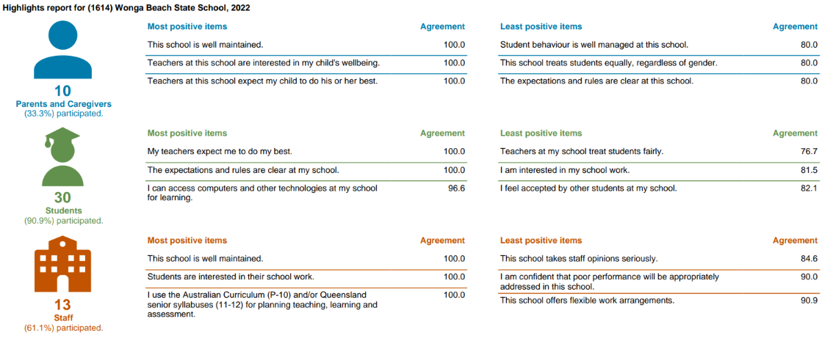

Overview of student behaviour in 2023
The following graph shows behaviour data from 2020-2022:
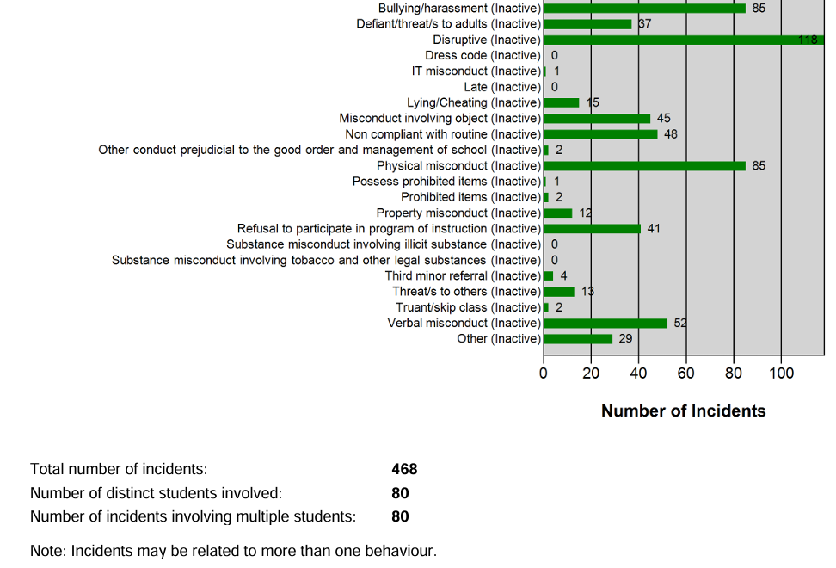

As the categories for recording behaviours changed in 2023, a seperate graph shows the behaviour data from 2023:
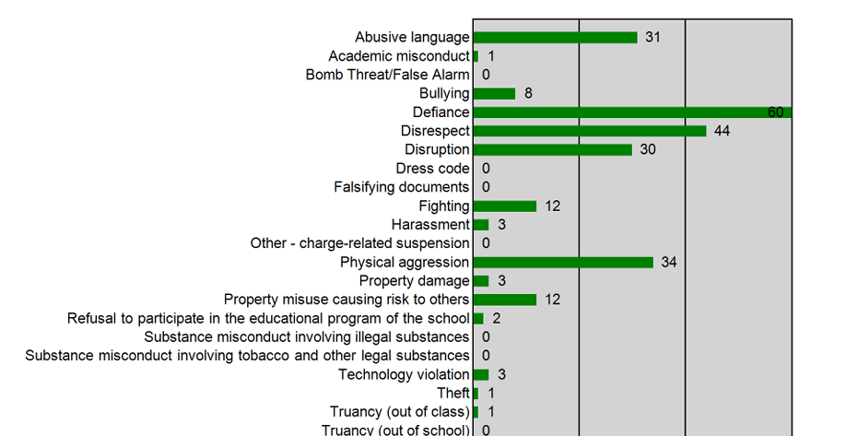

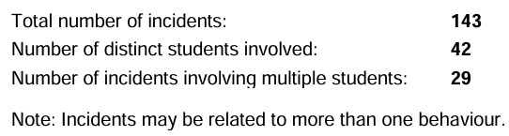

Within these graphs, the highest number of behaviour incidents from 2020-2022 came from the following categories:
- Disruptive
- Bullying/harassment
- Physical misconduct

Furthermore, in 2023, the highest number of behaviour incidents came from following categories:
- Defiance
- Disrespect
- Physical aggression

These data points will guide our Student Code of Conduct for the next four years. This will include our explicit teaching programs, responses to behaviour and training for staff.

Student Disciplinary Absences (SDAs)
Principals use a range of disciplinary consequences to address inappropriate behaviour. Suspensions and exclusions are only used as a last resort option for addressing serious behaviour issues. Principals balance individual circumstances and the actions of the student with the needs and rights of school community members.

All state schools are required to report School Disciplinary Absences (SDA) for the school year in their school annual report. There are four main categories of SDA: short suspension, long suspension, exclusion and charge-related suspension.

Learning and Behaviour Statement
At Wonga Beach State School, behaviour management is considered to be an opportunity for valuable social learning as well as a means of maximising the success of students’ academic achievement.

Our school-wide framework for managing behaviour is Positive Behaviour for Learning (PBL). PBL is a proactive, systems-level approach that enables schools to effectively and efficiently support student and staff behaviour. This approach uses a data and evidence
based, school-wide tiered system of support which includes proactive and positive strategies for defining, teaching and supporting appropriate behaviours for all students to create safe, supportive and disciplined school environments. Through thorough review of data and supported implementation of effective systems and practices we strive for high
levels of improvement in student outcomes.

The Universal or Tier 1 Support level is for all staff and students at Wonga Beach State School. Some identified students may require further support to be successful in the schooling environment. Identified students are supported through Tier 2 Targeted and Tier 3 Intensive Support, targeted specifically to individual students in order to meet their needs and assist them to be successful in a mainstream schooling environment.

Whole School Approach to Discipline
As stated above, Wonga Beach State School uses Positive Behaviour for Learning (PBL) as the multi-tiered system of support for discipline in the school. This is a whole-school approach, used in all classrooms and programs offered, such as sporting activities and excursions.

PBL is an evidence-based framework used to:
- analyse and improve student behaviour and learning outcomes
- ensure that only evidence-based practices are used correctly by teachers to support students
- continually support staff members to maintain consistent school and classroom improvement practices.
At Wonga Beach State School we believe discipline is about more than punishment. It is a word that reflects our belief that student behaviour is a part of the overall teaching and learning approach in our school. Our staff take responsibility for making their expectations clear, for providing supportive instruction about how to meet these expectations and strive to use behavioural incidents as opportunities to re-teach.

The development of the Wonga Beach State School Student Code of Conduct is an opportunity to implement a consistent approach to teaching behaviour. The language and expectations of PBL can be used in any environment, including the home setting for students. Doing everything we can do to set students up for success is a shared goal of every parent and school staff member.

The first step in facilitating standards of positive behaviour is communicating those standards to all students. These standards are outlined in the Wonga Beach State School Behaviour Matrix. At Wonga Beach State School we emphasise the importance of directly teaching students the behaviours we want them to demonstrate at school. Communicating behaviour expectations is a form of universal behaviour support strategy directed towards all students designed to prevent problem behaviour and provides a framework for responding to unacceptable behaviour.

Any students or parents who have questions or would like to discuss the Student Code of Conduct or PBL are encouraged to speak with the class teacher or make an appointment to meet with the principal.

Essential Skills for Classroom Management (ESCM) is the minimum foundational set of behaviour management skills expected of all teaching staff at Wonga Beach State School. ESCM provide staff with the basis on which to acknowledge and correct student behaviours in our classrooms.

Wonga Beach staff are committed to delivering a high quality whole school approach to discipline where every student has access to a positive and productive teaching and learning environment and opportunities to engage in quality learning experiences and acquire values supportive of their lifelong wellbeing. The school community has identified the following three expectations to teach and promote high standards of responsible behaviour across our school community.
- Be Safe
- Be Respectful
- Be a Learner
At Wonga Beach State School student behaviour is a part of the overall teaching and learning approach in our school. Our staff take responsibility for making their expectations clear, for providing supportive instruction about how to meet these expectations and strive to use behavioural incidents as opportunities to re-teach.

The development of the Wonga Beach State School Student Code of Conduct is an opportunity to explain the PBL framework with parents and students, and gain their support to implement a consistent approach to teaching behaviour. The language and expectations of PBL can be used in any environment, including the home setting for students. Doing everything we can do to set students up for success is a shared goal of every parent and school staff member.

Consideration of Individual Circumstances
Staff at Wonga Beach State School take into account students’ individual circumstances, such as their behaviour history, disability, mental health and wellbeing, religious and cultural considerations, home environment and care arrangements when teaching expectations, responding to inappropriate behaviour or applying a disciplinary consequence.

In considering the individual circumstances of each student, we recognise that the way we teach, the support we provide and the way we respond to students will differ. This reflects the principle of equality, where every student is given the support they need to be successful. This also means that not everyone will be treated the same, because treating everyone the same is not fair.

For example, some students need additional support to interpret or understand an expectation. Others may benefit from more opportunities to practise a required skill or behaviour. For a small number of students, the use of certain disciplinary consequences may be considered inappropriate or ineffective due to complex trauma or family circumstances. These are all matters that our teachers and principal consider with each individual student in both the instruction of behaviour and the response to behaviour.

Our teachers are also obliged by law to respect and protect the privacy of
individual students, so while we understand the interest of other students, staff and parents to know what punishment another student might have received, we will not disclose or discuss this information with anyone but the student’s family. This applies even if the behavioural incident, such as bullying, involves your child. You can be assured that school staff take all matters, such as bullying, very seriously and will address them appropriately. We expect that parents and students will respect the privacy of other students and families.

If you have concerns about the behaviour of another student at the school, or the way our staff have responded to their behaviour, please make an appointment with the principal to discuss the matter.

Differentiated and Explicit Teaching
Wonga Beach State School’s Prevent Teach Reinforce model provides differentiated teaching to respond to the learning needs of all students. This involves teaching expected behaviours through common language, providing practical opportunities for students to practise these behaviours and targeted correction and feedback.

Teachers at Wonga Beach State School vary what students are taught, how they are taught and how students can demonstrate what they know as part of this differentiated approach to behaviour. These decisions about differentiated learning are made in response to student data, day to day monitoring, information provided to staff via One School applications and trauma informed practice.

There are three main layers to differentiation, as illustrated in the diagram below. This model is the same used for academic and pedagogical differentiation.
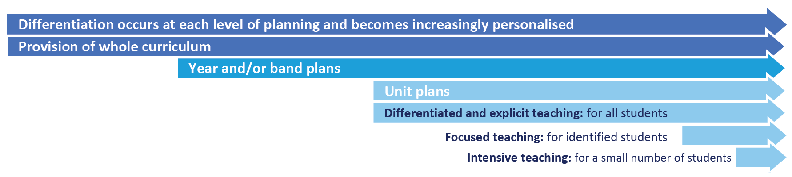

Focused Teaching

Approximately 15% of all students in any school or classroom may require additional support to meet behaviour expectations, even after being provided with differentiated and explicit teaching. These students may have difficulty meeting behavioural expectations in a particular period of the day or as part of a learning area/subject, and focused teaching is provided to help them achieve success.
Focused teaching involves revisiting key behavioural concepts and/or skills and using explicit and structured teaching strategies in particular aspects of a behaviour skill. Focused teaching provides students with more opportunities to practise skills and multiple opportunities to achieve the intended learning and expected behaviour.
Support staff, including teachers with specialist expertise in learning, language or development, work collaboratively with class teachers at Wonga Beach State School to provide focused teaching. Focused teaching is aligned to the PBL Expectations Matrix, and student progress is monitored by the classroom teacher/s to identify those who:
- no longer require the additional support
- require ongoing focussed teaching
- require intensive teaching

Intensive Teaching

Research evidence shows that even in an effective, well-functioning school there will always be approximately 5% of the student population who require intensive teaching to achieve behavioural expectations. Intensive teaching involves frequent and explicit instruction, with individuals or in small groups, to develop mastery of basic behavioural concepts, skills and knowledge.

Some students may require intensive teaching for a short period, for particular behaviour skills. Other students may require intensive teaching for a more prolonged period. Decisions about the approach will be made based on data collected from their teacher or teachers, and following consultation with the student’s family.

For a small number of students who continue to display behaviours that are deemed complex and challenging, then individualised, function-based behaviour assessment and support plans and multi-agency collaboration may be provided to support the student. This approach will seek to address the acute impact of barriers to learning and participation faced by students who are negotiating a number of complex personal issues.

Students who require intensive teaching will be assigned an individual mentor at the school that will oversee the coordination of their program, communicate with stakeholders and directly consult with the student.

Intensive Support may include:
- Risk Management Plans
- Behaviour Support Plans
- Individualised Student Timetables
- Stakeholder Meetings
- Referrals to external support agencies

Legislative Delegations
Legislation
In this section of the Student Code of Conduct provide links to relevant legislation that inform the overall Student discipline procedure.

- Anti-Discrimination Act 1991 (Qld)
- Child Protection Act 1999 (Qld)
- Disability Discrimination Act 1992 (Cwth)
- Disability Standards for Education 2005 (Cwth)
- Criminal Code Act 1899 (Qld)
- Education (General Provisions) Act 2006 (Qld)
- Education (General Provisions) Regulation 2017 (Qld)
- Human Rights Act 2019 (Qld)
- Information Privacy Act 2009 (Qld)
- Judicial Review Act 1991 (Qld)
- Right to Information Act 2009 (Qld)
- Police Powers and Responsibilities Act 2000 (Qld)
- Work Health and Safety Act 2011 (Qld)
- WorkHealth and Safety Regulations 2011 (Cwth)

Disciplinary Consequences

The disciplinary consequences model used at Wonga Beach State School follows the same differentiated approach used in the proactive teaching and support of student behavioural expectations.

The majority of students will be confident and capable of meeting established expectations that are clear, explicitly taught and practised. In-class corrective feedback, sanctions and rule reminders may be used by teachers to respond to low-level or minor problem behaviours.

Some students will need additional support, time and opportunities to practise expected behaviours. Approximately 15% of the student population may experience difficulty with meeting the stated expectations, and even with focussed teaching, in-class corrective feedback, sanctions and rule reminders continue to display low-level problem behaviour. A continued pattern of low-level behaviour can interfere with teaching and learning for the whole class, and a decision may be needed by the class teacher to refer the student to the school administration team immediately for determination of a disciplinary consequence.

For a small number of students, approximately 2-5%, a high level of differentiated support or intensive teaching is required to enable them to meet the behavioural expectations. This may be needed throughout the school year on a continuous basis. The determination of the need will be made by the principal in consultation with staff and other relevant stakeholders. On occasion the behaviour of a student may be so serious, such as causing harm to other students or to staff, that the principal may determine that an out of school suspension or exclusion is necessary as a consequence for the student’s behaviour. Usually this course of action is only taken when the behaviour is either so serious as to warrant immediate removal of the student for the safety of others, and no other alternative discipline strategy is considered sufficient to deal with the problem behaviour.
The differentiated responses to problem behaviour can be organised into three tiers, with increasing intensity of support and consequences to address behaviour that endangers others or causes major, ongoing interference with class or school operations.

Differentiated
Class teacher provides in-class or in-school disciplinary responses to low-level or minor problem behaviour. This may include:
- Pre-correction (e.g. “Remember, walk quietly to your seat”)
- Non-verbal and visual cues (e.g. posters, hand gestures)
- Whole class practising of routines
- Ratio of 5 positive to 1 negative commentary or feedback to class
- Corrective feedback (e.g. “Hand up when you want to ask a question”)
- Rule reminders (e.g. “When the bell goes, stay seated until I dismiss you”)
- Explicit behavioural instructions (e.g. “Pick up your pencil”)
- Proximity control
- Tactical ignoring of inappropriate behaviour (not student)
- Revised seating plan and relocation of student/s
- Individual positive reinforcement for appropriate behaviour
- Classwide incentives
- Reminders of incentives or class goals
- Redirection
- Low voice and tone for individual instructions
- Give 30 second ‘take-up’ time for student/s to process instruction/s
- Reduce verbal language
- Break down tasks into smaller chunks
- Provide positive choice of task order (e.g. “Which one do you want to start with?”)
- Prompt student to take a break or time away in class
- Model appropriate language, problem solving and verbalise thinking process (e.g. “I’m not sure what is the next step, who can help me?”)
- Provide demonstration of expected behaviour
- Peer consequence (e.g. corrective feedback to influential peer demonstrating same problem behaviour)
- Private discussion with student about expected behaviour
- Reprimand for inappropriate behaviour
- Warning of more serious consequences (e.g. removal from classroom)

Focussed
Class teacher is supported by other school-based staff to address in-class problem behaviour. This may include:
- Functional Behaviour Assessment
- Individual student behaviour support strategies (e.g. Student behaviour plan)
- Targeted skills teaching in small group
- Token economy
- Detention
- Behavioural contract
- Counselling and guidance support
- Self-monitoring plan
- Check in Check Out strategy
- Teacher coaching and debriefing
- Referral to Student Support Network for team based problem solving
- Stakeholder meeting with parents and external agencies

Intensive
School leadership team work in consultation with Student Support Network to address persistent or ongoing serious problem behaviour. This may include:
- Functional Behaviour Assessment based individual support plan
- Complex case management and review
- Stakeholder meeting with parents and external agencies including regional specialists
- Temporary removal of student property (e.g. mobile phone)
- Short term suspension (up to 10 school days)
- Long term suspension (up to 20 school days)
- Charge related suspension (student has been charged with a serious criminal offence is suspended from school until the charge has been dealt with by the relevant justice authorities)
- Suspension pending exclusion (student is suspended from school pending a decision by the Director-General or delegate (principal) about their exclusion from school)
- Exclusion (student is excluded from a particular state school site, a group of state schools or all state schools in Queensland for a defined period of time or permanently)
- Cancellation of enrolment for students older than compulsory school age who refuse to participate in the educational program provided at the school.

School Disciplinary Absences
A School Disciplinary Absence (SDA) is an enforced period of absence from attending a Queensland state school, applied by the Principal as a consequence to address poor student behaviour. There are four types of SDA:
- Short suspension (1 to 10 school days)
- Long suspension (11 to 20 school days)
- Charge-related suspension
- Exclusion (period of not more than one year or permanently).

At Wonga Beach State School, the use of any SDA is considered a very serious decision. It is typically only used by the Principal when other options have been exhausted or the student’s behaviour is so dangerous that continued attendance at the school is considered a risk to the safety or wellbeing of the school community.

Parents and students may appeal a long suspension, charge-related suspension or exclusion decision. A review will be conducted by the Director-General or their delegate, and a decision made within 40 schools days to confirm, amend/vary or set aside the original SDA decision by the Principal.
The appeal process is a thorough review of all documentation associated with the SDA decision and provides an opportunity for both the school and the family to present their case in the matter. Time is afforded for collection, dissemination and response to the materials by both the school and the family. It is important that the purpose of the appeal is understood so that expectations are clear, and appropriate supports are in place to ensure students can continue to access their education while completing their SDA.

Re-entry following suspension
Students who are suspended from Wonga Beach State School may be invited to attend a re-entry meeting on the day of their scheduled return to school. The main purpose of this meeting is to welcome the student, with their parent/s, back to the school. The aim of the re-entry meeting is for school staff to set the student up for future success and strengthen home-school communication.
It is not mandatory for the student or their parents to attend a re-entry meeting. It may be offered as a support for the student to assist in their successful re-engagement in school following suspension.

Reasonable adjustments
In planning the re-entry meeting, school staff will consider reasonable adjustments needed to support the attendance and engagement of the student. This includes selecting an appropriate and accessible meeting space, organising translation or interpretation services or supports (e.g. AUSLAN), provision of written and/or pictorial information and other relevant accommodations. The inclusion of support staff, such as guidance officers or Community Education Counsellors, may also offer important advice to ensure a successful outcome to the re-entry meeting.

School Policies
Wonga Beach State School has tailored school discipline policies designed to ensure students, staff and visitors work cooperatively to create and maintain a supportive and safe learning environment. Please ensure that you familiarise yourself with the responsibilities for students, staff and visitors outlined in the following policies:
- Temporary removal of student property
- Use of mobile phones and other devices by students
- Preventing and responding to bullying
- Appropriate use of social media

Temporary removal of student property

The removal of any property in a student’s possession may be necessary to promote the caring, safe and supportive learning environment of the school, to maintain and foster mutual respect between all state school staff and students. The Temporary removal of student property by school staff procedure outlines the processes, conditions and responsibilities for state school principals and school staff when temporarily removing student property.
In determining what constitutes a reasonable time to retain student property, the principal or state school staff will consider:
- the condition, nature or value of the property
- the circumstances in which the property was removed
- the safety of the student from whom the property was removed, other students or staff members
- good management, administration and control of the school.

The Principal or state school staff determine when the temporarily removed student property can be returned, unless the property has been handed to the Queensland Police Service.
The following items are explicitly prohibited at Wonga Beach State School and will be removed if found in a student’s possession:
- illegal items or weapons (e.g. guns, knives*, throwing stars, brass knuckles, chains)
- imitation guns or weapons
- potentially dangerous items (e.g. blades, rope)
- drugs** (including tobacco)
- alcohol
- aerosol deodorants or cans (including spray paint)
- explosives (e.g. fireworks, flares, sparklers)
- flammable solids or liquids (e.g. fire starters, mothballs, lighters)
- poisons (e.g. weed killer, insecticides)
- inappropriate or offensive material (e.g. racist literature, pornography, extremist propaganda).

* No knives of any type are allowed at school, including flick knives, ballistic knives, sheath knives, push daggers, trench knives, butterfly knives, star knives, butter knives, fruit knives or craft knives, or any item that can be used as a weapon, for example a chisel. Knives needed for school activities will be provided by the school, and the use of them will be supervised by school staff. In circumstances where students are required to have their own knives or sharp tools for particular subjects or vocational courses, the school will provide information about the procedures for carrying and storing these items at school.
** The administration of medications to students by school staff is only considered when a prescribing health practitioner has determined that it is necessary or when there is no other alternative in relation to the treatment of a specific health need. Schools require medical authorisation to administer any medication to students (including over-the-counter medications such as paracetamol or alternative medicines).
Responsibilities
State school staff at Wonga Beach State School:
- do not require the student’s consent to search school property such as lockers, desks or laptops that are supplied to the student through the school;
- may seize a student’s bag where there is suspicion that the student has a dangerous item (for example, a knife) in their school bag, prior to seeking consent to search from a parent or calling the police;
- consent from the student or parent is required to examine or otherwise deal with the temporarily removed student property. For example, staff who temporarily remove a mobile phone from a student are not authorised to unlock the phone or to read, copy or delete messages stored on the phone;
- there may, however, be emergency circumstances where it is necessary to search a student’s property without the student’s consent or the consent of the student’s parents (e.g. to access an EpiPen for an anaphylactic emergency);
- consent from the student or parent is required to search the person of a student (e.g. pockets or shoes). If consent is not provided and a search is considered necessary, the police and the student’s parents should be called to make such a determination.

Parents of students at Wonga Beach State School ensure your children do not bring property onto schools grounds or other settings used by the school (e.g. camp, sporting venues) that:
- is prohibited according to the Wonga Beach State School Student Code of Conduct
- is illegal
- puts the safety or wellbeing of others at risk
- does not preserve a caring, safe, supportive or productive learning environment
- does not maintain and foster mutual respect;
- collect temporarily removed student property as soon as possible after they have been notified by the Principal or state school staff that the property is available for collection.

Students of Wonga Beach State School do not bring property onto school grounds or other settings used by the school (e.g. camp, sporting venues) that:
- is prohibited according to the Wonga Beach State School Code of Conduct
- is illegal
- puts the safety or wellbeing of others at risk
- does not preserve a caring, safe, supportive or productive learning environment
- does not maintain and foster mutual respect;
- collect their property as soon as possible when advised by the Principal or state school staff it is available for collection.

Use of mobile phones and other devices by students

Queensland state schools are committed to reducing the distraction of mobile devices to provide optimal learning
environments for all students. For the purpose of this procedure, mobile devices include mobile phones, wearables such as smartwatches, handheld devices and other emerging technologies which have the ability to connect to telecommunication
networks or the internet.

- All state school students must keep mobile phones switched off and ‘away for the day’ during school hours.
- Wearable devices, such as smartwatches, must have notifications switched off so that phone calls, messages and other notifications cannot be sent or received during school hours.

Students and their parents may apply for an exemption from this requirement based on certain criteria. Students
with pre-existing school approval to use a mobile device on an ongoing basis to support certain medical, disability
and/or wellbeing needs will not need to reapply under this procedure.

What does ‘away for the day’ look like at Wonga Beach State School?
All students are to hand their mobile phones into the school office as soon as they arrive at school. For example, if a student arrives at 8:15am, their phone needs to be handed in at 8:15am. This is to avoid students using their phones before learning starts at 8:50am. These phones will be stored on our Business Manager’s desk, or if the parent/family are concerned about security, in the strong room that can only be accessed by the Business Manager and the Principal.

Furthermore, when students hand in their phones, they must ensure that notifications are turned off so that they do not disturb the office staff.

What does ‘notifications switched off on wearable devices’ look like at Wonga Beach State School?
Students who have a wearable device will need to ensure that when they are on school grounds, the student can only access the following applications/information:
- Time
- Calendar

Depending on the device, this will mean your device is in one of the following modes:
- School mode
- Airplane mode
- Do not disturb mode
- A similar mode that ensures students can only access the time and the calendar application

If a staff member suspects that a child is accessing other applications, such as the camera, or is receiving text or phone notifications, they will be referred to the Principal. The Principal will then contact the parent/family member to seek permission to check their device is on the correct mode.

Applying for an exemption
Should a parent or family member want to apply for an exemption to this requirement, they need to contact the Principal and arrange a meeting. The criteria that will be considered for exemption will be medical, disability or wellbeing needs. The final outcome of the exemption will be determined by the Principal.

School camps and excursions
Should a student wish to bring their mobile phone on a school camp or excursion, they will need to hand it in to the supervising teacher/s. Students will only be able to access their phone under the supervision of a staff member. Students will be highly discouraged from bringing mobile phones with them to camp, as the supervising staff will have their mobile devices and contact lists for all families. Therefore, if an emergency arises or a parent/family member needs to be contacted, the staff member will be able to facilitate this with the student.

Should a student wish to bring their wearable device, such as smartwatch, to camp or an excursion, they will need to have notification turned off for the entirety of the activity. This is to encourage students to be actively engaged and participating in all activities. If they wish to enable the notifications to contact their parent or family member, this can be done under staff supervision.

Preventing and responding to bullying

Wonga Beach State School uses the Australian Student Wellbeing Framework to promote positive relationships and the wellbeing of all students, staff and visitors at the school.
Our staff know student learning is optimised when they feel connected to others and experience safe and trusting relationships. Students who feel secure are more likely to be active participants in their learning and to achieve better physical, emotional, social and educational outcomes. Teachers who feel valued and supported are more likely to engage positively with students and build stronger connections within the school community. Parents who are positively engaged with their child’s education leads to improved student self-esteem, attendance and behaviour at school. Enhancing the wellbeing of students and their educators delivers overall long-term social, health and economic benefits to the Australian community.

Wonga Beach State School has a Student Council with year 6 leaders who meet regularly with the school leadership team to promote strategies to improve student wellbeing, safety and learning outcomes. The standing items on the agenda for each Student Leadership Forum are the core elements of the Australian Student Wellbeing Framework:
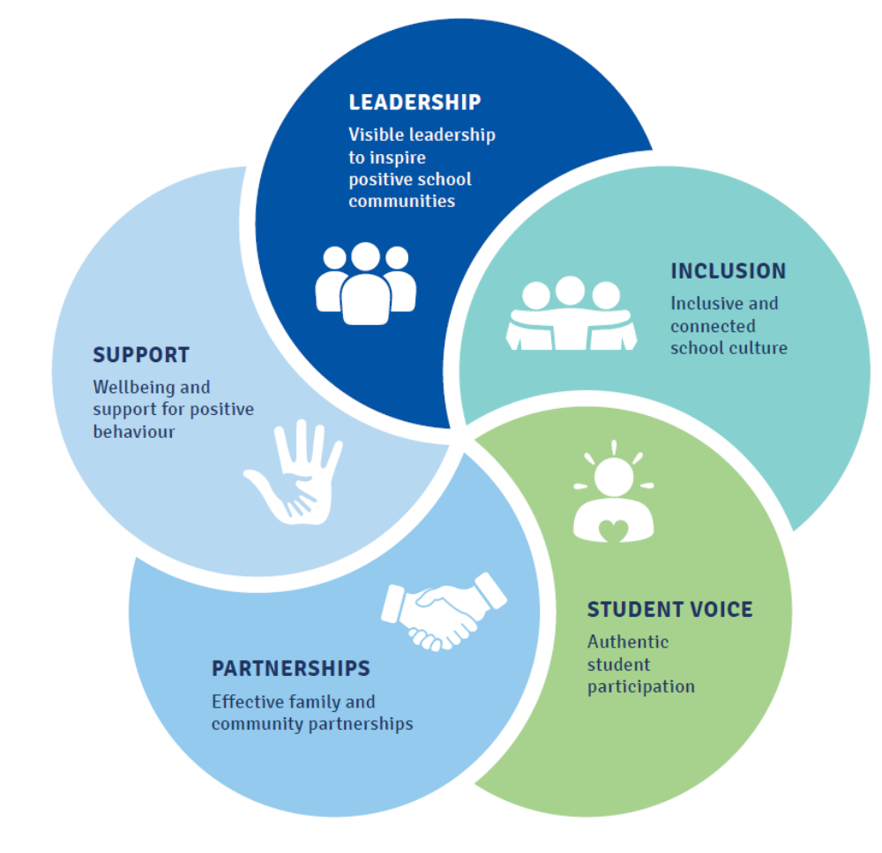

1. Leadership
Principals and school leaders playing an active role in building a positive learning environment where the whole school community feels included, connected, safe and respected.

2. Inclusion
All members of the school community actively participating in building a welcoming school culture that values diversity, and fosters positive, respectful relationships.

3. Student voice
Students actively participate in their own learning and wellbeing, feel connected and use their social and emotional skills to be respectful, resilient and safe.

4. Partnerships
Families and communities collaborating as partners with the school to support student learning, safety and wellbeing.

5. Support
School staff, students and families sharing and cultivating an understanding of wellbeing and positive behaviour and how this supports effective teaching and learning.

A priority for the Student Council is contributing to the implementation of strategies that enhance wellbeing, promote safety and counter violence, bullying and abuse in all online and physical spaces. The engagement of young people in the design of technology information and digital education programs for parents was a key recommendation from the Queensland Anti-Cyberbullying Taskforce report in 2018, and at Wonga Beach State School we believe students should be at the forefront of advising staff, parents and the broader community about emerging issues and practical solutions suitable to different contexts.

Bullying
The agreed national definition for Australian schools describes bullying as
- ongoing and deliberate misuse of power in relationships through repeated verbal, physical and/or social behaviour that intends to cause physical, social and/or psychological harm;
- involving an individual or a group misusing their power, or perceived power, over one or more persons who feel unable to stop it from happening;
- happening in person or online, via various digital platforms and devices and it can be obvious (overt) or hidden (covert). Bullying behaviour is repeated, or has the potential to be repeated, over time (for example, through sharing of digital records);
- having immediate, medium and long-term effects on those involved, including bystanders. Single incidents and conflict or fights between equals, whether in person or online, are not defined as bullying.

Behaviours that do not constitute bullying include:
- mutual arguments and disagreements (where there is no power imbalance)
- not liking someone or a single act of social rejection
- one-off acts of meanness or spite
- isolated incidents of aggression, intimidation or violence.

However, these conflicts are still considered serious and need to be addressed and resolved. At Wonga Beach State School our staff will work to quickly respond to any matters raised of this nature in collaboration with students and parents.
The following flowchart explains the actions Wonga Beach State School teachers will take when they receive a report about student bullying, including bullying which may have occurred online or outside of the school setting. Please note that the indicative timeframes will vary depending on the professional judgment of teachers who receive the bullying complaint and their assessment of immediate risk to student/s.

Bullying response flowchart for teachers
Please note these timelines may be adjusted depending on the unique circumstances and risk associated with each situation. This is at the professional judgment of the staff involved. Timeframes should be clearly discussed and agreed with student and family.
Key contacts for students and parents to report bullying:
Prep to Year 6 – Class teacher
Year 7 to Year 12 – Form teacher or Year Level Coordinator
Dean of Students – Malcolm Smith, 07 5555 5555

First hour
Listen
- Provide a safe, quiet space to talk
- Reassure the student that you will listen to them
- Let them share their experience and feelings without interruption
- If you hold immediate concerns for the student's safety, let the student know how you will address these. Immediate in this circumstance is where the staff member believes the student is likely to experience harm (from others or self) within the next 24 hours
- Continue to check in with student on regular basis until concerns have been mitigated
- Record notes of follow-up meetings in OneSchool
- Refer matter to specialist staff within 48 hours if problems escalate
- Look for opportunities to improve school wellbeing for all students
Ongoing
Follow up
- Evaluate the information to determine if bullying has occurred or if another disciplinary matter is at issue
- Make a time to meet with the student to discuss next steps
- Ask the student what they believe will help address the situation
- Provide the student and parent with information about student support network
- Agree to a plan of action and timeline for the student, parent and yourself
Day three
Discuss
- Ask the student for examples they have of the alleged bullying (e.g. hand written notes or screenshots)
- Write a record of your communication with the student
- Check back with the student to ensure you have the facts correct
- Enter the record in OneSchool
- Notify parent/s that the issue of concern is being investigated
Day one
Document
- Gather additional information from other students, staff or family
- Review any previous reports or records for students involved
- Make sure you can answer who, what, where, when and how
- Clarify information with student and check on their wellbeing
Day two
Collect
- Document the plan of action in OneSchool
- Complete all actions agreed with student and parent within agreed timeframes
- Monitor the student and check in regularly on their wellbeing
- Seek assistance from student support network if needed
Day four
Implement
- Meet with the student to review situation
- Discuss what has changed, improved or worsened
- Explore other options for strengthening student wellbeing or safety
- Report back to parent
- Record outcomes in OneSchool
Day five
Review
Appropriate use of social media

The internet, mobile phones and social media provide wonderful opportunities for students to network and socialise online. While these technologies provide positive platforms for sharing ideas, they also have the potential to cause pain and suffering to individuals, groups or even whole communities.
It’s important to remember that sometimes negative comments posted about the school community have a greater impact than expected. This guide offers some information about how to use social media in relation to comments or posts about the school community. Reputations of students, teachers, schools, principals and even parents can be permanently damaged — and in some cases, serious instances of inappropriate online behaviour are dealt with by police and the court system.

Being aware of a few simple strategies can help keep the use of social media positive and constructive:
- Before you post something online, ask yourself if the community or individual really need to know.
- Is it relevant, positive and helpful?
- Remember that what you post online is a direct reflection of who you are. People will potentially form lasting opinions of you based on what you post online.
- Be a good role model. If things get heated online consider logging out and taking a few moments to relax and think. Hasty, emotive responses could inflame situations unnecessarily.
- Be mindful when commenting, try to keep general and avoid posting anything that could identify individuals.
- A few years ago parents may have discussed concerns or issues with their friends at the school gate. Today with the use of social media, online discussions between you and your close friends can very quickly be shared with a much wider audience, potentially far larger than intended.
- Taking a few moments to think about the content you are about to post could save upset,

- embarrassment, and possible legal action.
- As a parent you have a role in supervising and regulating your child’s online activities at home and its impact on the reputation and privacy of others. Parents are their child’s first teachers — so they will learn online behaviours from you.

Is it appropriate to comment or post about schools, staff or students?
Parental and community feedback is important for schools and the department. If you have a compliment, complaint or enquiry about an issue at school, the best approach is to speak directly to the school about the matter, rather than discussing it in a public forum.
While many schools use social media to update parents of school notices, the department prefers that parents contact schools directly with a compliment, complaint or enquiry due to privacy considerations. Imagine if your doctor, accountant or banking institution tried to contact you to discuss important matters via Facebook.
If you have raised an issue with a school or know that another person has, consider refraining from discussing those details on social media, particularly the names of anyone involved.

Keep comments calm and polite, just as you would over the telephone or by email. If you encounter negative or derogatory content online which involves the school, hinders a child’s learning and/or affects the school community at large, contact the school principal.

Possible civil or criminal ramifications of online commentary
A serious instance of inappropriate online behaviour may constitute a criminal offence and become a police matter. For example, online content may substantiate the offence of ‘using a carriage service to menace, harass or cause offence’ (Criminal Code Act 1995 (Cth) s. 474.17). School staff may contact their union or obtain personal legal advice if they feel that online content seriously impacts their reputation. Defamatory online content may give rise to litigation under the Defamation Act 2005 (Qld).

What about other people’s privacy?
If you upload photos of your children, be mindful of who might be in the background. You might be happy to share your child’s successes with your friends and family via social media, but some parents are not. If you are tagging or naming students, consider that other parents may not want their child’s name attached to images online.

What if I encounter problem content?
Taking the following steps may help resolve the issue in a constructive way:
- refrain from responding
- take a screen capture or print a copy of the concerning online content
- if you consider problem content to be explicit, pornographic or exploitative of minors, you should keep a record of the URL of the page containing that content but NOT print or share it. The URL can be provided to the school principal, or police, as needed for escalation of serious concerns
- block the offending user
- report the content to the social media provider.

Cyberbullying response flowchart for school staff

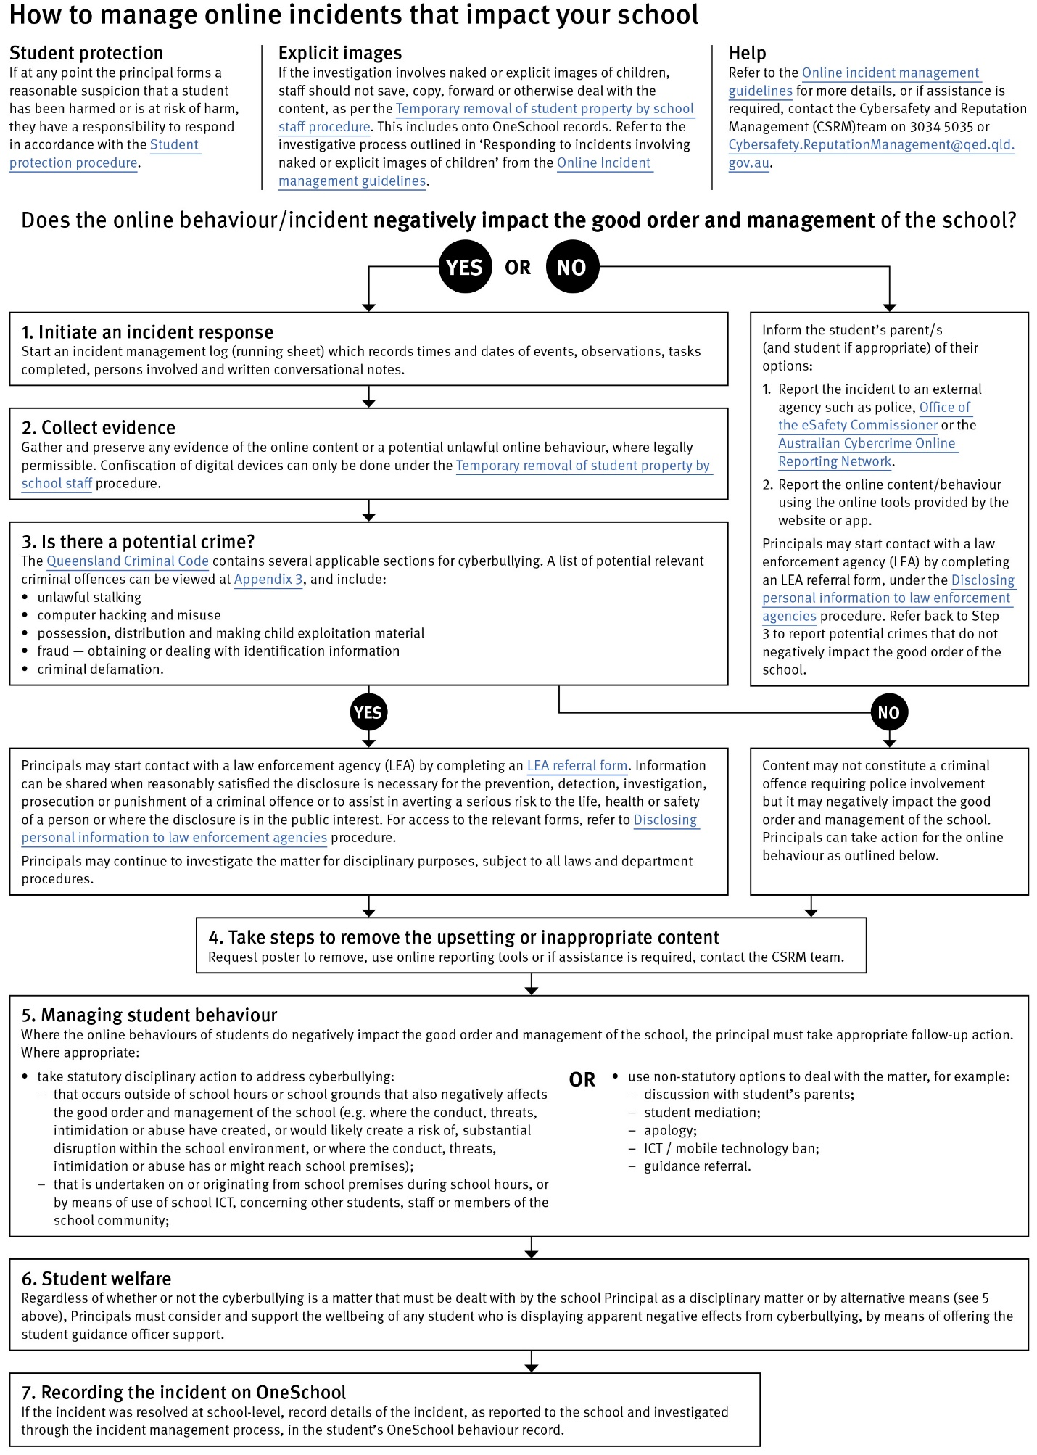
Restrictive Practices

School staff at Wonga Beach State School may need to respond to student behaviour that presents a risk of physical harm to the student themselves or others. It is anticipated that most instances of risky behaviour can be de-escalated and resolved quickly. On some rarer occasions, a student’s behaviour may continue to escalate and staff need to engage immediately with positive and proactive strategies aimed at supporting the student to manage their emotional arousal and behaviour.

In some very rare situations, where there is immediate risk of physical harm to the student or other people, and when all other alternative strategies have failed to reduce the risk, it may be necessary for staff to use restrictive practices.

The use of restrictive practices will always be as a last resort, when there is no other available option for reducing immediate risk to the student, staff or other people. Restrictive practices are not used for punishment or as a disciplinary measure.

The department’s Restrictive practices procedure is written with consideration for the protection of everyone’s human rights, health, safety and welfare. There are six fundamental principles:
1. Regard to the human rights of those students
2. Safeguards students, staff and others from harm
3. Ensures transparency and accountability
4. Places importance on communication and consultation with parents and carers
5. Maximises the opportunity for positive outcomes, and
6. Aims to reduce or eliminate the use of restrictive practices.

Very rarely restrictive practices will be planned and staff will employ, when necessary, pre-arranged strategies and methods (of physical restraint/ mechanical restraint/ clinical holding) which are based upon behaviour risk assessment or clinical health need and are recorded in advance. The use of planned strategies will only be where there is foreseeable immediate risk consistent with the restrictive practices procedure.

Seclusion will not be used as a planned response and will only be used in serious circumstances for managing an unforeseeable situation in an emergency. It will be used for the shortest time possible and in a safe area that presents no additional foreseeable risk to the student. In such emergencies, a staff member will observe the student at all times and seclusion will cease as soon as possible.

Following the use of any restrictive practice, a focused review will help staff to understand how they responded to the risk in any incident that involved the use of a restrictive practice. Staff will consider whether there are other options for managing a similar situation in the future. This strategy works well for reducing the use of restrictive practices.

All incidents of restrictive practices will be recorded and reported in line with departmental procedures.

Critical Incidents

It is important that all school staff have a consistent understanding of how to respond in emergencies involving student behaviour that seriously endangers the student or others. This consistency ensures that appropriate actions are taken to ensure that both students and staff are kept safe.
A critical incident is defined as an occurrence that is sudden, urgent, and usually unexpected, or an occasion requiring immediate action (e.g. in the community, on the road). The aim in these situations is to bring the behaviour of the student under rapid and safe control. It is not a time to try and to punish or discipline the student; it is a crisis management period only.
Staff should follow the documented plan for any student involved in regular critical incidents, which should be saved and available for staff to review in OneSchool.
For unexpected critical incidents, staff should use basic defusing techniques:
1. Avoid escalating the problem behaviour: Avoid shouting, cornering the student, moving into the student’s space, touching or grabbing the student, sudden responses, sarcasm, becoming defensive, communicating anger and frustration through body language.

2. Maintain calmness, respect and detachment: Model the behaviour you want students to adopt, stay calm and controlled, use a serious measured tone, choose your language carefully, avoid humiliating the student, be matter of fact and avoid responding emotionally.

3. Approach the student in a non-threatening manner: Move slowly and deliberately toward the problem situation, speak privately to the student/s where possible, speak calmly and respectfully, minimise body language, keep a reasonable distance, establish eye level position, be brief, stay with the agenda, acknowledge cooperation, withdraw if the situation escalates.

4. Follow through: If the student starts displaying the appropriate behaviour briefly acknowledge their choice and re-direct other students’ attention towards their usual work/activity. If the student continues with the problem behaviour, then remind them of the expected school behaviour and identify consequences of continued unacceptable behaviour.

5. Debrief: At an appropriate time when there is low risk of re-escalation, help the student to identify the sequence of events that led to the unacceptable behaviour, pinpoint decision moments during the sequence of events, evaluate decisions made, and identify acceptable decision options for future situations

Related Procedures and Guidelines

These are related procedures or guidelines which school staff use to inform decisions and actions around matters associated with students wellbeing, behaviour and learning. This may include reference to

- Cancellation of enrolment
- Complex case management
- Customer complaints management policy and procedure
- Disclosing personal information to law enforcement agencies
- Enrolment in state primary, secondary and special schools
- Hostile people on school premises, wilful disturbance and trespass
- Inclusive education
- Police and Child Safety Officer interviews and searches with students
- Restrictive practices
- Refusal to enrol – Risk to safety or wellbeing
- Student discipline
- Student dress code
- Student protection
- Supporting students’ mental health and wellbeing
- Temporary removal of student property by school staff
- Use of ICT systems
- Using mobile devices

